A514-Am,S- Ecuador-Valdivia-Female-Pointed legs-3500-2000 BCE



Fig. 1. Ecuador-Valdivia-Female-Pointed legs-3500-2000 BCE

Case No.: 9

**Accession No.**

**Formal Label:** Ecuador-Valdivia-Female-Lacking legs-3500-2000 BCE

**Display Description:**

Valdivia Culture flourished on the Pacific coastal lowlands of Ecuador during the Early Formative period (3500-2000 BCE) making it one of the earliest cultures of the Americas. It was identified at the type site of Valdivia in coastal Guayas province by the Ecuadoran Emilio Estrada, and U. S. archaeologists Betty Meggers and Clifford Evans in the late 1950s.

Valdivia culture was initially thought to be an egalitarian, semi-sedentary littoral adaptation based upon fishing and shellfish gathering, with only rudimentary reliance on horticulture. Today this view of Valdivian culture has been revised to be a tropical forest culture" having a fundamentally riverine settlement focus, whose ultimate origins can be traced to early population dispersals from the Amazon Basin. Newer subsistence data indicate a mixed economy of flood plain horticultural production (based on maize, beans, manioc, achira and other root crops, chili pepper, cotton, and gourds), hunting, fishing, and the gathering of wild plants and shellfish. Its unique ceramic style and the so-called "Venus" figurines remain as its trademark.

An eight-phase ceramic sequence established by Betsy Hill has permitted a more precise delineation of temporal trends in settlement pattern and internal site layout. Large-scale excavations at village sites such as Real Alto and Loma Alta in Guayas province have generated detailed reconstructions of Valdivia households, community patterning, social organization, burial practices, and ceremonial behavior, all of which underwent significant changes between phases 1 and 8. As a result, it is now clear that Valdivia represents a dynamic, fully sedentary society of village horticulturalists, characterized by progressive demographic growth, household expansion from nuclear to extended family dwellings, and an increasing degree of social ranking and status inequality through time. Beginning as early as Middle Valdivia times, mortuary evidence suggests the establishment of hereditary social status accorded to senior females. Long-distance maritime trade was apparent from exotic material excavated in village sites and this probably generated societal change and heightened complexity.

**LC Classification:**

**Date or Time Horizon:** 3500-1800 BCE

**Geographical Area:** [Santa Elena](https://en.wikipedia.org/wiki/Santa_Elena_Province) peninsula near the modern-day town of [Valdivia](https://en.wikipedia.org/w/index.php?title=Valdivia,_Ecuador&action=edit&redlink=1), [Ecuador](https://en.wikipedia.org/wiki/Ecuador).

**Map:**

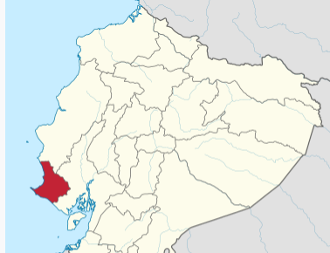

[Santa Elena](https://en.wikipedia.org/wiki/Santa_Elena_Province) peninsula in Ecuador. After https://upload.wikimedia.org/wikipedia/commons/thumb/1/15/Santa_Elena_in_Ecuador_%28%2BGalapagos%29.svg/375px-Santa_Elena_in_Ecuador_%28%2BGalapagos%29.svg.png

**GPS coordinates:**

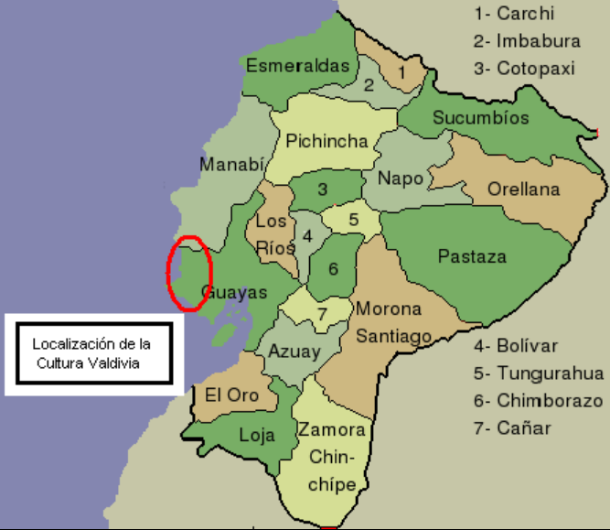

Valdivian culture area in red after Alfredobi Own work assumed (based on copyright claims)., Public Domain, https://commons.wikimedia.org/w/index.php?curid=1267392

**Cultural Affiliation:**

**Medium: ceramic**

**Dimensions: 76.43 mm, 3.0 in**

**Weight:**

**Condition: original**

**Provenance: English 1930’s collection**

**Discussion:**

“The provocative theory of Meggers, Evans, and Estrada that the Valdivia pottery of Ecuador owes its inception to lost Middle Jomon fishermen from Kyushu, Japan (Meggers, Evans, and Estrada 1965; Meggers 1966; Meggers and Evans 1966) has been reviewed by a number of Americanists (Coe 1967; Ferdon 1966; Lathrap 1967). Dr. Lathrap pointed out several aspects of the authors’ interpretive sections that seemed questionable to him. … the Jomon traits they have selected in no way demonstrate the existence of a prehistoric community from which migrants could have drifted to the New World (Pearson 1978)” “Meggers’ and Evans’ theory of diffusion from the Neolithic Jomon culture of Japan, which seemed to share some similarities in ceramic design (McEwan 1978), was marred by the fact they did not seek possible correlations between the Valdivia and other regional groups such as the sites of Real Alto and Las Vegas , which provided data showing the genesis and development of Valdivian culture.

**References:**

Chandler-Ezell, Karol, Deborah M. Pearsall, and James A. Zeidler. "Root and Tuber Phytoliths and Starch Grains Document Manioc (Manihot esculenta), Arrowroot (Maranta arundinacea), and Llerén (Calathea sp.) at the Real Alto Site, Ecuador." Economic Botany 60, no. 2 (2006): 103-120.

Estrada, Emilio. Valdivia: Un sitio arqueológico formativo en la Provincia del Guayas, Ecuador. Guayaquil, Ecuador: Museo Víctor Emilio Estrada, 1956.

Hill, Betsy D. "A New Chronology of the Valdivia Ceramic Complex from the Coastal Zone of Guayas Province, Ecuador." Ñawpa Pacha 10-12 (1972–1974): 1-32.

Lathrap, Donald W. Ancient Ecuador: Culture, Clay, and Creativity, 3000–300 b.c.Chicago: Field Museum of Natural History, 1975.

Lathrap, Donald W., Jorge G. Marcos, and James A. Zeidler. "Real Alto: An Ancient Ceremonial Center." Archaeology 30, no. 1 (1977): 2-13.

Marcos, Jorge G. Real Alto: La historia de un centro ceremonial Valdivia. 2 vols. Guayaquil, Ecuador: Escuela Politécnica del Litoral, Centro de Estudios Arqueológicos y Antropológicos; Quito, Ecuador: Corporación Editora Nacional, 1988.

Marcos, Jorge G. Los pueblos navegantes del Ecuador prehispánico. Quito, Ecuador: Ediciones Abya-Yala, 2005.

Meggers, Betty J. Ecuador. [New York](https://www.encyclopedia.com/places/united-states-and-canada/us-political-geography/new-york): Praeger; London: Thames and Hudson, 1966.

Meggers, Betty J., Clifford Evans, and Emilio Estrada. Early Formative Period of Coastal Ecuador: The Valdivia and Machalilla Phases. Washington, DC: [Smithsonian Institution](https://www.encyclopedia.com/literature-and-arts/art-and-architecture/art-museums/smithsonian-institution), 1965.

Pearsall, Deborah M., Karol Chandler-Ezell, and James A. Zeidler. "Maize in Ancient Ecuador: Results of Residue Analysis of Stone Tools from the Real Alto Site." Journal of Archaeological Science 31, no. 4 (April 2004): 423-442.

Pearson, Richard. Migration from Japan to Ecuador: the Japanese Evidence.

Perry, Linda et al. "Starch Fossils and the Domestication and Dispersal of Chili Peppers (Capsicum spp. L.) in the Americas." Science 315, no. 5814 (16 February 2007): 986-988.

Raymond, Scott. "Ceremonialism in the Early Formative of Ecuador." Senri Ethnological Studies 37 (1993): 25-43.

Staller, John E. "Late Valdivia Occupation in Southern Coastal El Oro Province, Ecuador: Excavations at the Early Formative Period (3500–1500 bc) Site of La Emerenciana." Ph.D. diss., Southern Methodist University, 1994.

Staller, John E. "Figurinas Valdivia VII-VIII del sitio San Lorenzo del Mate, provincia del Guayas, y la Transición Valdivia-Machalilla." Miscelánea Antropológica Ecuatoriana 9 (2000): 99-133.

Zeidler, James A. "Maritime Exchange in the Early Formative Period of Coastal Ecuador: Geopolitical Origins of Uneven Development." Research in Economic Anthropology 13 (1991): 247-268.

Zeidler, James A. "Cosmology and Community Plan in Early Formative Ecuador: Some Lessons from Tropical Ethnoastronomy." Journal of the Steward Anthropological Society 26, nos. 1-2 (1998): 37-68.

Zeidler, James A. "Gender, Status, and Community in Early Formative Valdivia Society." In The Archaeology of Communities: A New World Perspective, edited by Marcello A. Canuto and Jason Yaeger. London and [New York](https://www.encyclopedia.com/places/united-states-and-canada/us-political-geography/new-york): Routledge, 2000.

Zeidler, James A., Peter Stahl, and Marie J. Sutliff. "Shamanistic Elements in a Terminal Valdivia Burial, Northern Manabí, Ecuador: Implications for Mortuary Symbolism and Social Ranking." In Recent Advances in the Archaeology of the Northern Andes: Essays in Honor of Gerardo Reichel-Dolmatoff, edited by Augusto Oyuela-Caycedo and J. Scott Raymond. [Los Angeles](https://www.encyclopedia.com/places/united-states-and-canada/us-political-geography/los-angeles): Cotsen Institute of Archaeology, [University of California](https://www.encyclopedia.com/social-sciences-and-law/education/colleges-us/university-california), [Los Angeles](https://www.encyclopedia.com/places/united-states-and-canada/us-political-geography/los-angeles), 1998.